Experiment 1 Introduction to MATLAB Basics

Objectives

- To get familiar with the MATLAB working environment.
- To get familiar with how to declare and process matrices.
- To get familiar with simple plot commands.

Procedure

Section-1
MATLAB is usually used in a command-driven mode. When single-line commands are entered, MATLAB processes these commands immediately and displays the result. MATLAB is also capable of executing sequences of commands that are stored in files. The commands that are typed may be accessed later by using the up-arrow key.

- Statements and Variable: The following command is used to declare a variable a. A value of 10 is assigned to this variable.

>>a = 10 ;

The semicolon is used to suppress the output on the display. Use the same statement without semicolon as shown below and press the enter key.

>>a = 10

What is the output of this command?

- The following command is used to declare a matrix of two row and three columns.

>>b = [1 2 3; 4 5 6] ;

The matrix variable b can be displayed by just typing b and pressing the enter key.
How this variable id displayed on the screen?

The variable b can also be displayed on the screen by entering the above command without using semicolon at the end of the statement. Note that the semicolon used inside the square brackets is used to separate rows of the matrix.

- To address a single element in a given matrix,

>>b(1,2) or
>>f12 = b(1,2)

- The following command is used to obtain the list of variables in the workspace with the variable name, size, number of bytes etc.

>>whos

- Several statements can be placed on one line if they are separated by commas or semicolons as shown below.

>>x = [10 20 5] ; y = [2 4 6] ; m = 15 ;

Now enter the command who and whos to see all the workspace variables.

- Interestingly, the MATLAB can be used in the calculator mode. When the variable name and “= “ are omitted, from an expression, the result is assigned to the generic variable ans. The result is displayed immediately after pressing the enter key if the expression is not terminated by the semicolon as shown below.

>>22/7

If the output is suppressed by terminating the expression by semicolon, the result can be displayed by entering ans as shown below.

>>2*10 ;
>>ans

Section-2
- In MATLAB, the basic computational unit is the matrix. Vectors and scalars are special cases of matrices. Matrix dimensions must be compatible for matrix operations. Following are few examples.

>>a = [1 2 3; 4 5 6] ;
>>b = [2 2 2; 3 3 3] ;
>>c = [4 3 2; 1 0 2; 7 2 1] ;

What is result of the following command?

>>d= a + b

What is result of the following command?

>>d= a + c

The reason of error in the above statement is obvious.

- Enter the following command for matrix multiplication. Note that these operations are performed on the matrix variables declared in the previous step.

>>a*c

What is the result of this command?

Now enter the following command and write the result.

>>a*b

MATLAB has a large set of powerful matrix manipulation commands. It is not possible to exercise all these commands in this introductory session.

- Write three loop current equations for the following circuit.

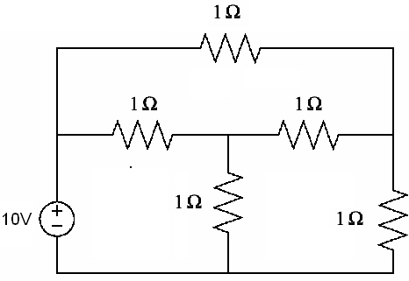
I₁

I₂ I₃

Loop-1:

Loop-2:

Loop-3:

Write all the matrices required to calculate I₁, I₂ and I₃ use Cramer’s rule.

Δ =

I₁ = I₂ = I₃ =

Now write the MATLAB command to calculate I₁, I₂ and I₃ in the following space.

What are the values returned by the MATLAB?

I₁ = I₂ = I₃ =

- Matrix representation can be used for the loop equations of the circuit shown above as IR=V, where R is the resistance matrix, I is the current matrix and V is the voltage matrix. Once these matrices are declared, currents can be calculated as I=R⁻¹V. Once all the matrices are defined, enter the following MATLAB command

>>I = inv(R)*V

Now show how the MATLAB returns values of I₁, I₂ and I₃ in the following space.

Section-3
In this section you will learn how to plot a function using MATLAB.

MATLAB has a variety of powerful commands used to plot variable(s). Few examples are given below.

- MATLAB uses a colon notation to generate a row vector. The following statement generates a row vector t with starting value of 0 and a final value of 1 with an increment of 0.1.

>>t = 0 : 0.1 : 1 ;

Write all the value of t returned by the MATLAB.

- Size of a variable can be obtained as following.

>>size(t)

What is displayed by the MATLAB?

- Now write

>>length(t)

What is the difference between size() and length() ?

- Following statements are used to generate a sinusoidal function with 50Hz frequency.

>>t = 0 : 0.002 : 0.04 ;
>>y = sin(2*pi*50*t) ;
>>plot(t, y) ;
>>grid ;
>>xlabel(‘time (s)’) ;
>>ylabel(‘y’) ;
>>title(‘sin(2*pi*50*t)’) ;

The plot you will see is not smooth as it has only 10 values in one cycle.

What you can do to have 100 values in one cycle?

- The following statements are used to plot three-phase voltage at 50Hz.

>>t = 0 : 0.0002 : 0.04 ;
>>y1 = sin(2*pi*50*t) ;
>>y2 = sin(2*pi*50*t – 2*pi/3) ;
>>y3 = sin(2*pi*50*t + 2*pi/3) ;
>>figure ;
>>hold ;
>>plot(t, y1, ‘r’) ;
>>plot(t, y2, ‘b’) ;
>>plot(t, y3, ‘g’) ;
>>grid ;

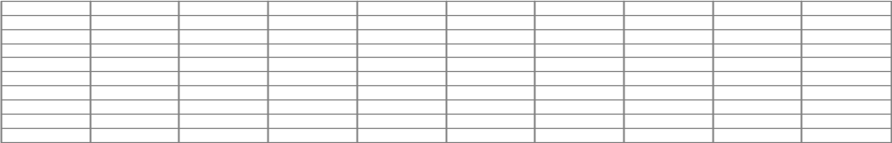
Sketch the plot.

- Following command is used to obtain a 3D plot of variable y1, y2 and y3 used in the previous step.

>>plot3(y1, y2, y3) ;

- You will observe interesting patterns of 3D plot by changing the phase angle of one or more variable (y1, y2, y3).

Exercise

In this section you will write MATLAB statements to evaluate the following time functions.

y = e^{-at}sin(ωt)

Write MATLAB statements to evaluate y for the following parameters.
t=0 to 1s with an increment of 2 ms.
Time constant (τ) = 0.25s. where τ = 1/a .
f = 10Hz. where ω = 2πf.

Sketch the plot of y Vs t.

What is the peak of the output at t = 1τ y =
t = 4τ y =

Note: A MATLAB tutorial at the end of the textbook is also very helpful for the introduction purpose.

Write your comments on this experiment.

……………………………………………………………………………………………
……………………………………………………………………………………………
……………………………………………………………………………………………
……………………………………………………………………………………………
……………………………………………………………………………………………
……………………………………………………………………………………………
……………………………………………………………………………………………
……………………………………………………………………………………………
……………………………………………………………………………………………
……………………………………………………………………………………………
……………………………………………………………………………………………
……………………………………………………………………………………………

Checked by: Date:

